Regulatory Committee
Meeting to be held on 9th March 2022

Part I

Electoral Division affected:
Farington East

Wildlife and Countryside Act 1981
Definitive Map Modification Order Investigation
Addition of Footpath through Farington Hall Wood, Leyland
(Annex ‘A’ refers)

Contact for further information (quoting ref. 804-691):
Ansar Sadiq, 01772 532435, Paralegal Officer. Legal Governance and Registrars, ansar.sadiq@lancashire.gov.uk
Jayne Elliott, 01772 537663, Public Rights of Way Definitive Map Officer, Planning and Environment Group, jayne.elliott@lancashire.gov.uk

Brief Summary

Application for the addition of a Footpath through Farington Hall Wood, Leyland to the Definitive Map and Statement of Public Rights of way for Lancashire.

Recommendation

That the application for a footpath through Farington Hall Wood, Leyland be

accepted.

That an Order be made pursuant to Section 53 (2)(b) and Section 53 (3)(b)

and/or] Section 53 (3)(c)(i) of the Wildlife and Countryside Act 1981 to add footpaths through Farington Hall Wood on the Definitive Map and Statement of Public Rights of Way as shown on Committee Plan between points A-B-C-D and E-F.

That being satisfied that the higher test for confirmation can be met the Order

be promoted to confirmation.

Detail

An application under Schedule 14 of the Wildlife and Countryside Act 1981 has been received for the addition of a footpath through Farington Hall Wood on the Definitive Map and Statement of Public Rights of Way.

The county council is required by law to investigate the evidence and make a decision based on that evidence as to whether a public right of way exists, and if so its status. Section 53(3)(b) and (c) of the Wildlife and Countryside Act 1981 set out the tests that need to be met when reaching a decision; also current Case Law needs to be applied.

An order will only be made to add a public right of way to the Definitive Map and Statement if the evidence shows that:
- A right of way “subsists” or is “reasonably alleged to subsist”

An order for adding a way to or upgrading a way shown on the Definitive Map and Statement will be made if the evidence shows that:
- “the expiration… of any period such that the enjoyment by the public…raises a presumption that the way has been dedicated as a public path or restricted byway”

When considering evidence, if it is shown that a highway existed then highway rights continue to exist (“once a highway, always a highway”) even if a route has since become disused or obstructed unless a legal order stopping up or diverting the rights has been made. Section 53 of the Wildlife and Countryside Act 1981 makes it clear that considerations such as suitability, the security of properties and the wishes of adjacent landowners cannot be considered. The Planning Inspectorate’s website also gives guidance about the interpretation of evidence.

The county council’s decision will be based on the interpretation of the evidence discovered by officers and documents and other evidence supplied by the applicant, landowners, consultees and other interested parties produced to the county council before the date of the decision. Each piece of evidence will be tested, and the evidence overall weighed on the balance of probabilities. It is possible that the council’s decision may be different from the status given in any original application. The decision may be that the routes have public rights as a footpath, bridleway, restricted byway or byway open to all traffic, or that no such right of way exists. The decision may also be that the routes to be added or deleted vary in length or location from those that were originally considered.

Consultations

South Ribble Borough Council

South Ribble Borough Council provided no response to consultation.

Applicant/Landowners/Supporters/Objectors

The evidence submitted by the applicant/landowners/supporters/objectors and observations on those comments are included in Advice – Head of Service – Legal and Democratic Services Observations.

Advice

Head of Service – Planning and Environment

Points annotated on the attached Committee plan.

Point | Grid Reference (SD) | Description
A | 5372 2324 | Kissing gate providing access into the woodland at junction with Leyland Footpath 35 (Hall Lane)
B | 5380 2323 | Junction of paths
C | 5384 2318 | Application route crosses stream
D | 5384 2318 | Unmarked point on boundary of two different landownerships
E | 5378 2322 | Junction with Bluebell Wood
F | 5379 2322 | Kissing gate providing access into the woodland adjacent to 9 Bluebell Wood
n.b. 'Bluebell Wood' and 'Parish Gardens', mentioned below, are names of roads on the housing estate.

Description of Route

A site inspection was carried out in February 2021.

The route commences at a point on Hall Lane (Leyland Footpath 35) where access is prevented by a recently erected wooden fence and padlocked gate (point A). From the gate the application route enters Farington Hall Wood and runs in a generally east north easterly and then south easterly direction through the woodland to the rear of residential housing. A further access point into the woodland was included as part of the application route from a point at the northern end of Bluebell Wood, point E on the Committee plan, across a grassed area for approximately 5 metres to a wooden kissing gate providing access to the woodland at point F.

When the application route was inspected in February 2021 it was found that access to the woodland through which the route ran had been blocked by wooden fencing at points A and F and that it was not possible to walk the route.

Parts of the route could be viewed from looking over the fencing and a kissing gate existed at point F behind which the fencing which prevented access had been built.

Photographs included later in this report, and submitted by the applicant show the route prior to it being obstructed in November 2020 and these photographs together with recently produced OS mapping show that a surfaced pathway existed from point A along the route applied for passing through point B to point C and to point D. In addition, the photographic and map evidence show that a surfaced route – together with steps down a steep slope – existed between points F-B.

On the day of inspection it was still possible to access point D and point C on the application route via a network of paths through the more south easterly part of Farington Hall Wood accessed from Parish Gardens. This part of the woodland is in separate landownership from the application route and a number of surfaced paths run through it which link to the application route at point D. Entering this part of the woodland from Parish Gardens there is a sign welcoming people to the wood and stating this area of open space is managed and maintained by Greenbelt Group Ltd.

One of the stone surfaced paths through the woodland which is described as open space on a sign located at the entrance into the woodland from Parish Gardens leads to point D which is an unmarked point at the top of a flight of wooden steps which then lead down a slope to a watercourse at point C. At point C there appear to be the remains of a path across the steam extending north west. However, a newly erected wooden fence prevents access along the application route from just north of point C.

The total length of the application route is approximately 180 metres.

Map and Documentary Evidence

A variety of maps, plans and other documents were examined to discover when the route came into being, and to try to determine what its status may be.

Document Title | Date | Brief Description of Document & Nature of Evidence
Yates’ Map  of Lancashire | 1786 | Small scale commercial map. Such maps were on sale to the public and hence to be of use to their customers the routes shown had to be available for the public to use. However, they were privately produced without a known system of consultation or checking. Limitations of scale also limited the routes that could be shown.
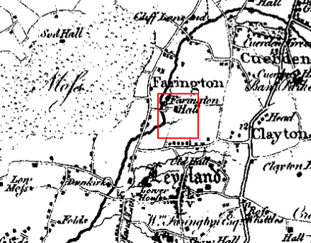
Observations |  | The application route is not shown. Hall Lane is shown extending north towards Farrington Hall and a watercourse can be seen crossing Hall Lane in proximity to point A but Farington Hall woods and the route are not shown.
Investigating Officer's Comments |  | The application route did not exist as a major route at that time although – as we are investigating an application for a footpath – it is possible that the route did exist but, due to limitations of scale and the purpose for which the map was drawn meant that that it would not have been shown so no inference can be drawn.
Greenwood’s Map of Lancashire | 1818 | Small scale commercial map. In contrast to other map makers of the era Greenwood stated in the legend that this map showed private as well as public roads and the two were not differentiated between within the key panel.
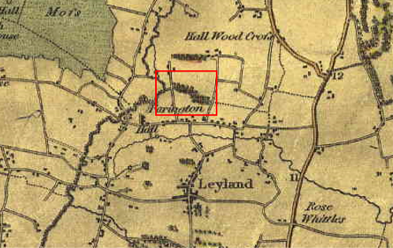
Observations |  | The application route is not shown but Hall Lane is clearly marked passing through point A and the woodland through which the application route runs is also shown to exist.
Investigating Officer's Comments |  | Access into the woodland may have existed in 1818 from point A but the application route, if it did exist – at least in part - is not shown.
Hennet's Map of Lancashire | 1830 | Small scale commercial map. In 1830 Henry Teesdale of London published George Hennet's Map of Lancashire surveyed in 1828-1829 at a scale of 7½ inches to 1 mile. Hennet's finer hachuring was no more successful than Greenwood's in portraying Lancashire's hills and valleys but his mapping of the county's communications network was generally considered to be the clearest and most helpful that had yet been achieved.
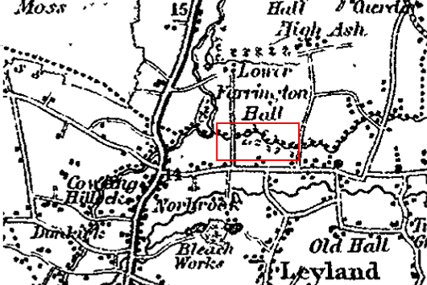
Observations |  | The application route is not shown. Hall Lane and the watercourse passing through the woodland are shown but the woodland itself is not clearly marked.
Investigating Officer's Comments |  | The application route did not exist as a major route in 1830 although it may have existed in part as a minor route so no inference can be drawn.
Canal and Railway Acts |  | Canals and railways were the vital infrastructure for a modernising economy and hence, like motorways and high-speed rail links today, legislation enabled these to be built by compulsion where agreement couldn't be reached. It was important to get the details right by making provision for any public rights of way to avoid objections but not to provide expensive crossings unless they really were public rights of way. This information is also often available for proposed canals and railways which were never built.
Observations |  | There are no canals or railways in existence across land crossed by the application route and no known proposals for either a canal or railway to have been constructed across the land in the past.
Investigating Officer's Comments |  | No inference can be drawn with regards to the existence of public rights.
Tithe Map and Tithe Award or Apportionment | 1838 | Maps and other documents were produced under the Tithe Commutation Act of 1836 to record land capable of producing a crop and what each landowner should pay in lieu of tithes to the church. The maps are usually detailed large scale maps of a parish and while they were not produced specifically to show roads or public rights of way, the maps do show roads quite accurately and can provide useful supporting evidence (in conjunction with the written tithe award) and additional information from which the status of ways may be inferred.
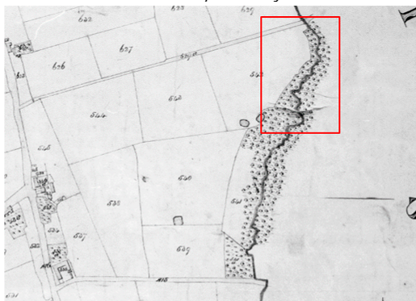
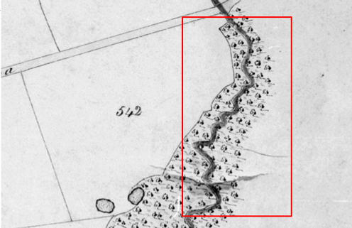
Observations |  | The application route is not shown. Hall Lane is marked passing through point A suggesting that access to the woodland may have existed from point A but there is no indication of a path through the wood and the land now developed for housing – including Summerfield and Bluebell Wood is shown as fields with no footpaths marked.
Investigating Officer's Comments |  | The application route probably did not exist in 1838.
Inclosure Act Award and Maps |  | Inclosure Awards are legal documents made under private acts of Parliament or general acts (post 1801) for reforming medieval farming practices, and also enabled new rights of way layouts in a parish to be made. They can provide conclusive evidence of status.
Observations |  | No Inclosure Award was found for the area crossed by the application route.
Investigating Officer's Comments |  | No inference can be drawn with regards to the existence of public rights.
6 Inch Ordnance Survey (OS) Map Sheet 69 | 1848 | The earliest Ordnance Survey 6 inch map for this area surveyed in 1844 to 1846 and published in 1848.
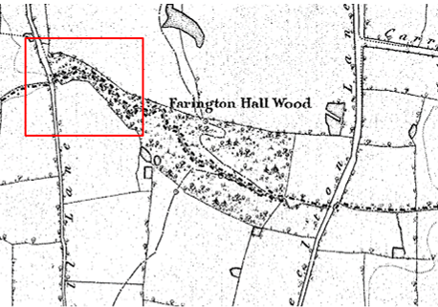
Observations |  | Hall Lane and Farington Hall Wood are shown but the application route is not shown and there are no other footpaths shown through the woods.
Investigating Officer's Comments |  | The application route probably did not exist in 1848.
25 Inch OS Map  Sheet LXIX.10 | 1894 | The earliest OS map at a scale of 25 inch to the mile. Surveyed in 1893 and published in 1894.
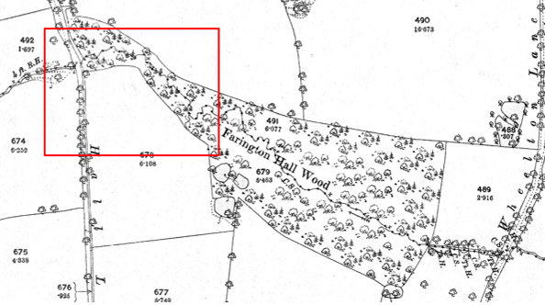
Observations |  | Hall Lane and Farington Hall Wood are shown but the application route is not shown and there are no other footpaths shown through the woods.
Investigating Officer's Comments |  | The application route did not exist in 1894.
Finance Act 1910 Map | 1910 | The comprehensive survey carried out for the Finance Act 1910, later repealed, was for the purposes of land valuation not recording public rights of way but can often provide very good evidence. Making a false claim for a deduction was an offence although a deduction did not have to be claimed so although there was a financial incentive a public right of way did not have to be admitted.  Maps, valuation books and field books produced under the requirements of the 1910 Finance Act have been examined. The Act required all land in private ownership to be recorded so that it could be valued and the owner taxed on any incremental value if the land was subsequently sold. The maps show land divided into parcels on which tax was levied, and accompanying valuation books provide details of the value of each parcel of land, along with the name of the owner and tenant (where applicable).  An owner of land could claim a reduction in tax if his land was crossed by a public right of way and this can be found in the relevant valuation book. However, the exact route of the right of way was not recorded in the book or on the accompanying map. Where only one path was shown by the Ordnance Survey through the landholding, it is likely that the path shown is the one referred to, but we cannot be certain. In the case where many paths are shown, it is not possible to know which path or paths the valuation book entry refers to. It should also be noted that if no reduction was claimed this does not necessarily mean that no right of way existed.
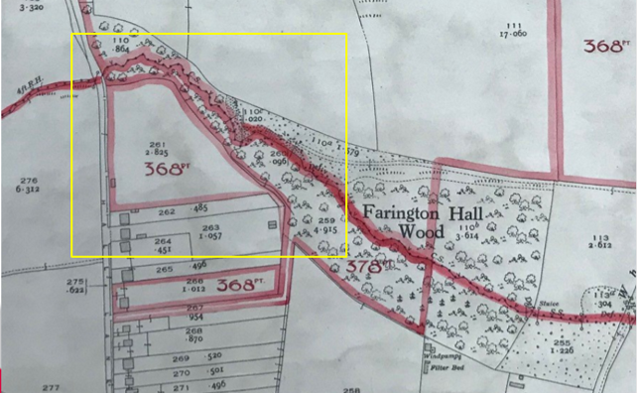
Observations |  | The land crossed by the application route is within plot 378 with the exception of the short section leading from Blue Bell Wood which lies within plot 368. Neither plot lists any deductions for rights of way or user.
Investigating Officer's Comments |  | The landowner did not appear to acknowledge the existence of a public right of way across the land over which the application route runs when the 1910 valuation was carried out.
25 Inch OS Map  Sheet LXIX.10 | 1911 | Further edition of 25 inch map (surveyed 1893, revised in 1909 and published in 1911.
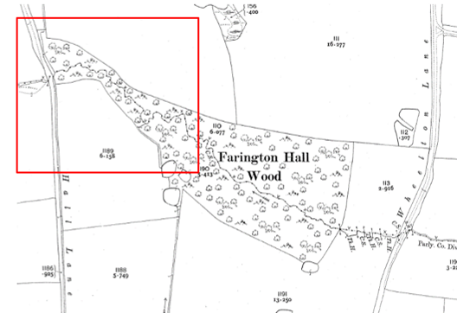
Observations |  | Hall Lane and Farington Hall Wood are shown but the application route is not shown and there are no other footpaths shown through the woods.
Investigating Officer's Comments |  | The application route probably did not exist in 1909.
Aerial Photograph | 1929 | Aerial photograph submitted by the applicant and available to view on the internet https://britainfromabove.org.uk/en/image/EPW026421
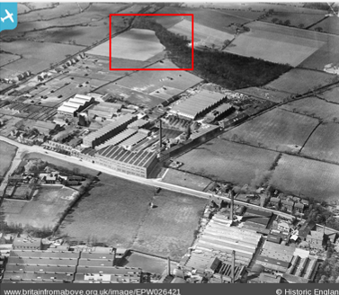
Observations |  | The photograph shows the woodland and Hall Lane. The land to the south of the woodland can be seen as fields and in the foreground is the Golden Hill Rubber Works.
Investigating Officer’s Comments |  | The photograph was submitted by the applicant to help to explain the history of the land over which the application route runs illustrating that in the early 1900s the land around the woods was fields.  The photograph does not show the application route which, even if it did exist in part at least, would be obscured by trees.
25 inch OS  Sheet LXIX-10 | 1931 | OS 25 inch map surveyed in 1893, revised in 1928 and published in 1931.
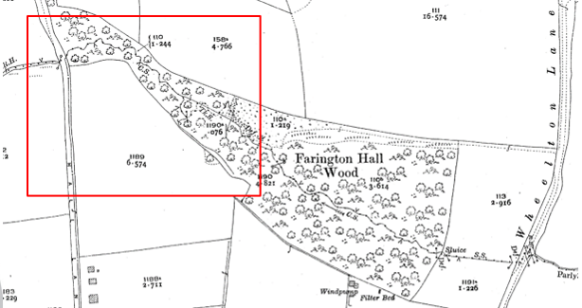
Observations |  | The land appears unaltered from how it was shown on earlier editions of OS mapping. Hall Lane and Farington Hall Wood are shown but the application route is not shown and there are no other footpaths shown through the woods.
Investigating Officer’s Comments |  | The application probably did not exist in 1928.
Authentic Map Directory of South Lancashire by Geographia | Circa1934 | An independently produced A-Z atlas of Central and South Lancashire published to meet the demand for such a large-scale, detailed street map in the area. The Atlas consisted of a large-scale coloured street plan of South Lancashire and included a complete index to streets which includes every 'thoroughfare' named on the map.  The introduction to the atlas states that the publishers gratefully acknowledge the assistance of the various municipal and district surveyors who helped incorporate all new street and trunk roads. The scale selected had enabled them to name 'all but the small, less-important thoroughfares'.
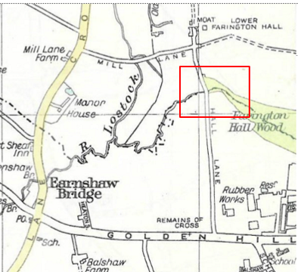
Observations |  | The application route is not shown.
Investigating Officer's Comments |  | This map would be unlikely to show woodland footpaths so no inference can be drawn.
Aerial Photograph | 1940s | The earliest set of aerial photographs generally looked at as part of applications were taken just after the Second World War in the 1940s and can be viewed on GIS. The clarity is generally very variable.
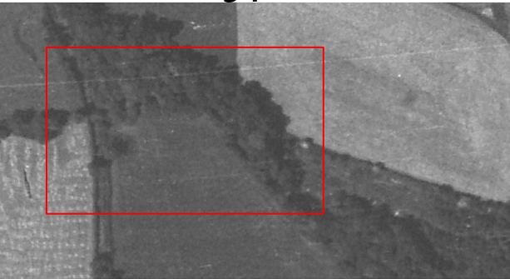
Observations |  | The aerial photograph shows the woodland in full leaf and as such it is not possible to see whether any paths exist under the tree cover. The is little indication of any paths leading to or from the woodland which would have suggested that the public were accessing the woods to walk.
Investigating Officer's Comments |  | No inference can be drawn regarding the existence of the application route through the woodland but there is no indication from the surrounding fields of trodden paths leading to or from the woodland in the 1940s.
25 inch OS Map  Sheet LXIX.10 | 1940 | 25 inch OS map surveyed 1893, revised 1938 and published 1940.
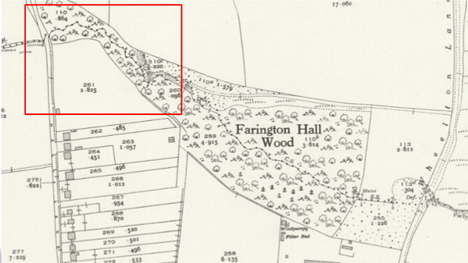
Observations |  | The application route is not shown. A track is now shown leading from Wheelton Lane extending west into Farington Hall Wood but does not connect to the application route and is shown to end on the north side of the watercourse.
Investigating Officer’s Comments |  | The application route probably did not exist in 1938.
6 Inch OS Map  Sheet SD 52SW | 1955 | The OS base map for the Definitive Map, First Review, was published in 1955 at a scale of 6 inches to 1 mile (1:10,560). This map was revised between 1930 and 1945.
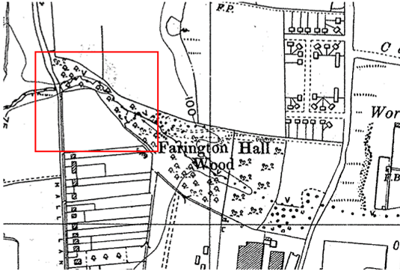
Observations |  | The application route is not shown. Tracks are shown leading into and through the wood east of the land crossed by the application route suggesting that access may now have been more easily available to the woods but there is no indication that the application route existed as a defined route.
Investigating Officer's Comments |  | The application route probably did not exist in the 1940s.
1:2500 OS Map  SD 5223-5323 | 1964 | Further edition of 25 inch map reconstituted from former county series part surveyed in 1960-61, revised in 1962 and published in 1964 as national grid series.
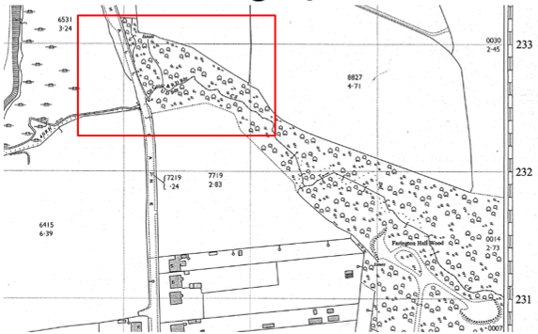
Observations |  | The application route is not shown. Tracks exist into and through the woods further east but are not shown connecting to the application route.
Investigating Officer's Comments |  | The application route probably did not exist in the early 1960s.
Aerial photograph | 1960s | The black and white aerial photograph taken in the 1960s and available to view on GIS.
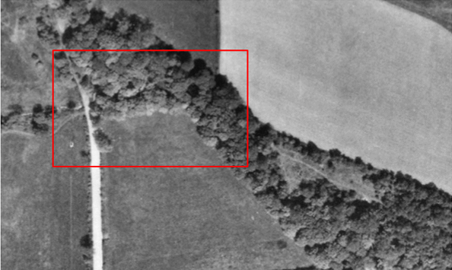
Observations |  | The application route is not visible although it is noted that the photograph was taken during the summer months and the trees are in full leaf. A track can be seen south east of the application route passing through a more open area of the woodland and a very faint path can be seen between Mill Lane and the woodland crossing the field south of the application route.
Investigating Officer's Comments |  | The aerial photograph does not help to establish whether the application route may have existed in the 1960s, It appears that there may have been some access to the woodland – and use of paths through it but whether this use was public or private and whether the application route – or any part of it existed, is not known.
1:10,560 OS Map  Sheet SD 52SW | 1967 | OS map revised 1960-1965 and published 1967.
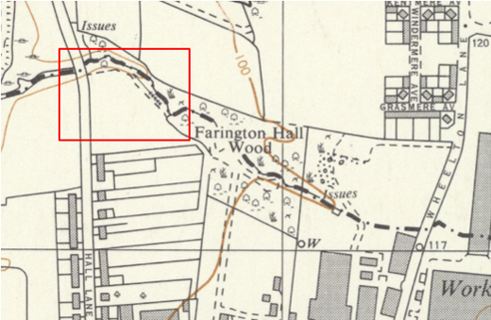
Observations |  | The application route is not shown. Again, routes are shown into and through the woodland east of the land crossed by the application route but the route itself is not shown.
Investigating Officer’s Comments |  | The application route probably did not exist in the 1960s.
OS Pathfinder 688 (SD 42/52)  Preston (South) & Leyland  1:25 000 | 1988 | OS map compiled from large scale surveys carried out between 1956 and 1973, revised for significant changes 1977, major roads revised 1978 and selected revisions 1981 and 1986.
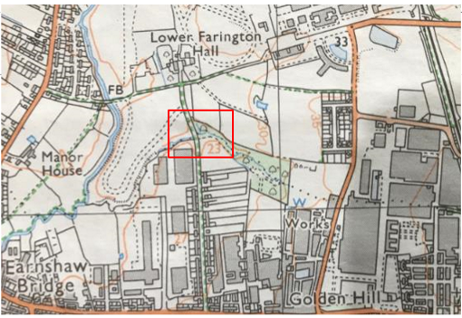
Observations |  | The application route is not shown and the land immediately to the south of the woodland crossed by the application route is still undeveloped.
Investigating Officer’s Comments |  | The application route probably did not exist in the 1980s.
Planning Application | 1995 | Planning application 07/1995/0674 for 44 dwelling houses, access roads and public open space.
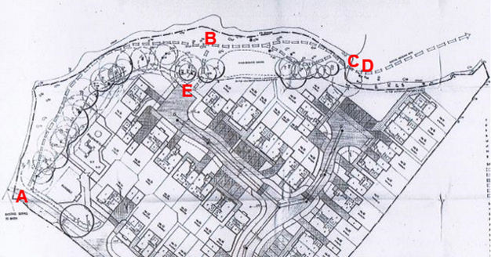

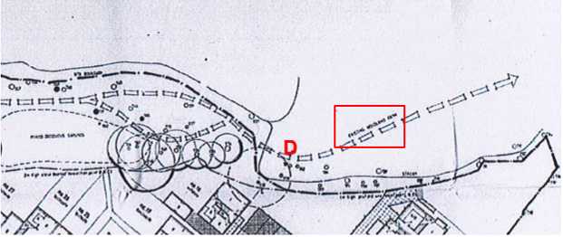

Observations |  | The applicant submitted extracts from the planning permission granted to Chapeltown Developments in 1995 for the development of the land immediately south of the woodland in 1995.  The planning application submitted to and subsequently agreed by South Ribble Borough Council was referenced 07/95/0674.  The Investigating Officer made contact with South Ribble Borough Council (SRBC) who provided a copy of the original planning report, Decision Notice and Plans.  The SRBC report details the land affected by the application as comprising approximately 1.3 hectares at the northern end of Hall Lane. The site is described as comprising of an open field, most recently used for grazing but prior to that was a private playing field for ‘BTR’ and part of the adjacent woodland named in the report as Farington Hall Wood which was stated to be protected by a woodland Tree Preservation Order.  With regards to access the report refers to the existence of the public footpath along Hall Lane which was to be retained as a pedestrian route. It then gives details of four areas proposed as ‘Public Open Space’ one of which is described as that part of Farington Hall Wood within the application site ‘with new properly constructed paths’ and goes on to say that all four of the sites would be offered for adoption to SRBC.  A quotation included within the report is taken from the applicant's aboricultural method statement and states that there was an existing public access to the woods from Hall Lane and that there existed through the woodland informal routes which, as a result of frequent use, had led to the exposure of tree routes and soil erosion. The report continues by stating that new public routes would be created leading from the development to the woodland trails which would themselves be upgraded and further into the report it states that the existing point of access from Hall Lane would be upgraded by the provision of a stile and kissing gate and that the existing route through the woodland would be surfaced.  The Decision Notice was issued by SRBC who approved the application on 7th February 1996 stating that the areas shown edged green on the approved plan must be laid out in full in accordance with the approved details as public open space and retained as such thereafter and that the area designated as public open space within Farington Hall Wood must be completed within 1 year from which any property on the site was first occupied.  The development was completed and from the site photographs and map evidence it appears that the routes were surfaced and that access was ‘formalised’ at point A. In addition it appears that access was provided from the newly built houses on Bluebell Wood via the application route between point E-F-B when the houses were built.
Investigating Officer’s Comments |  | The report prepared by SRBC in deciding whether or not to approve the application clearly refers to the fact that the application route already existed prior to the submission of the application as a substantial path through the woodland which was accessed from Hall Lane. Reference to the planning application map confirms that this access was at point A and that the route that existed was along the line A-B-C-D. The fact that use of the route was described as being frequent – which had led to the exposure of tree roots and soil erosion – suggested that this was already a well-used footpath by 1995. The application route between points E-F-B however, was clearly only constructed as part of the development following planning approval being granted in 1996.
Aerial Photographs | 2000 - 2020 | Aerial photographs available to view on Google Earth Pro spanning the 20 year period 2000 – 2020.
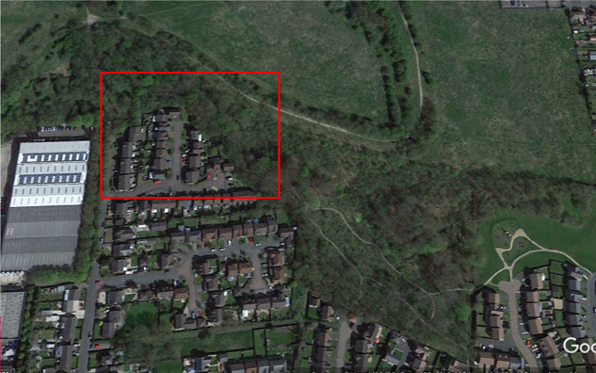

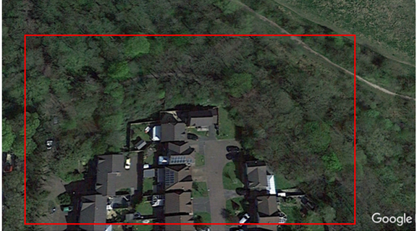
2015
Observations |  | Aerial photographs dated 2000, 2005, 2007, 2009, 2015, 2017 and 2020 which show the land crossed by the application route where viewed on Google Earth Pro. The photographs spanned the 20 year period prior to the route being blocked by fencing. The fact that the route ran through a woodland means that it was not possible to see whether the application route existed on any of the photographs taken during that time other than the photograph taken in 2015. The 2015 image shows traces of what appeared to be a significant track along part of the route between point A and point C.
Investigating Officer's Comments |  | The photographs are of very little assistance in determining whether the application route physically existed and was capable of being used in the 20 years prior to it being blocked.
Sales Brochure in association with the development |  | Extract from Sales Brochure published by Chapeltown Developments in 1996/1997.
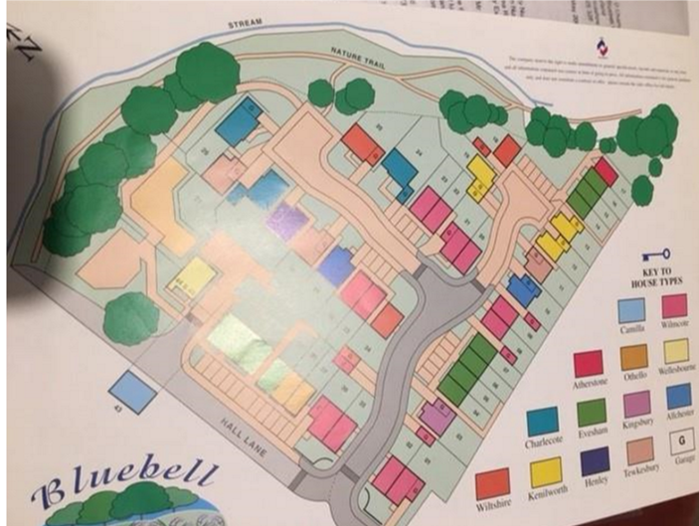
Observations |  | A photograph of a plan contained in a sales brochure for the development was submitted by the applicant. The Investigating Officer has not had sight of the whole document, but the extract submitted shows a plan of the site with the full length of the application route shown passing through the woodland and linking to the housing estate described as a nature trail.
Investigating Officer’s Comments |  | The plan submitted suggests that the full length of the application route would be in existence when the properties were being sold. There is no indication on the plan that the ‘nature trail’ was regarded as a public footpath but it is shown continuing east from the development suggesting that access was not exclusive to residents of the development.
South Ribble Orienteering club map | 2012 | Map submitted by the applicant and available to view online.
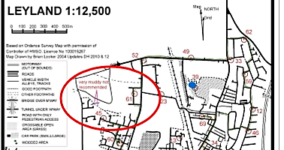
Observations |  | The orienteering map produced by South Ribble Orienteering club is based on OS mapping. The applicant included it as supporting evidence drawing attention to the fact that the application route was shown on the map and part of it was annotated as 'very muddy not recommended'.  The Investigating Officer obtained a copy of the map and on close inspection it appears that the application route is marked on the map as part of a longer route continuing south east from point D. The application route is marked on the map as a ‘Good Footpath’ south of an area of land described as being very muddy and not to be recommended.
Investigating Officer’s Comments |  | The fact that the route is marked on the map suggests that it was being used by the public in 2012 and that its existence was known locally. The description of the route as a ‘good footpath’ however appears to refer more to its condition and is not indicative of its public status.
Work carried out to surface the route | 2014 | Details regarding work carried out by South Ribble Borough Council and Lancashire County Council in 2014.
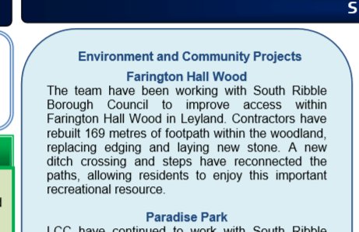
Observations |  | The applicant submitted an extract from a bulletin published by Lancashire County Council’s Environment Directorate in 2014 detailing work carried out in South Ribble. Within the bulletin was a section titled Farington Hall Wood where it was documented that the County Council’s Environmental Project Team had been working with South Ribble Borough Council to improve access to the woodland.  The Officer involved in the work recalled that Lancashire County Council funded the work on what he described as being an existing trodden path which linked from Hall Lane at point A through to an existing network of paths south of point D. This would appear to be the application route. He explained that the work to surface the paths and to provide steps and a ditch crossing was done following agreement from the landowner who he recalled at that time being the developer who built the houses north of the route. The County Council Officer explained that prior to the work being carried out the application route already existed on the ground but was muddy with some particularly boggy sections. He recalled that the project was carried out to enhance existing public access to the wood And there was not any restriction on access while work was carried out
Investigating Officer’s Comments |  | The County Council were involved in a project to improve existing public access to the woodland in 2014. The County Council Officer confirmed that work carried out was along the application route and funded on the basis that there was continuing public access along the route.  There is no suggestion that the work to improve the paths in 1995/1996 was not carried out and the bulletin refers to 'rebuilt' and 'replacing' clearly indicating that the footpath had been created previously and benefited from restoration. It is not uncommon for constructed routes within woodlands to deteriorate quite quickly and to become muddy due to the fact that in dense woodland the path may not get much sunlight and is sheltered from the wind leaving it more prone to becoming wet and boggy and not drying out as readily as paths that are more exposed to the elements. 20 years is about the expected timescale for such infrastructure needing repair and renewal. The fact that the County Council part funded this work suggests that the route was being well used and that the landowner at that time was allowing open access as was required as part of the planning conditions to be implemented. It does not however appear that the land had been transferred to SRBC as public open space as it was suggested could be done in consideration of the original planning application.
Definitive Map Records |  | The National Parks and Access to the Countryside Act 1949 required the County Council to prepare a Definitive Map and Statement of Public Rights of Way.  Records were searched in the Lancashire Records Office to find any correspondence concerning the preparation of the Definitive Map in the early 1950s.
Parish Survey Map | 1950-1952 | The initial survey of public rights of way was carried out by the parish council in those areas formerly comprising a rural district council area and by an urban district or municipal borough council in their respective areas. Following completion of the survey the maps and schedules were submitted to the County Council. In the case of municipal boroughs and urban districts the map and schedule produced, was used, without alteration, as the Draft Map and Statement. In the case of parish council survey maps, the information contained therein was reproduced by the County Council on maps covering the whole of a rural district council area. Survey cards, often containing considerable detail exist for most parishes but not for unparished areas.
Observations |  | The land crossed by the application route is part of the former urban district of Leyland for which no parish survey was carried out.
Planning Compliance Issues | 2020 | Contact was made with SRBC Planning Compliance and Monitoring Officers following submission of the application regarding the erection of the fence and to obtain information about the designation of the land as public open space.
Observations |  | The SRBC Planning Officer explained that they had been contacted regarding the erection of the fencing across the application route in November 2020.  They confirmed that the conditions were complied with at the time of the development and that the access route through the woodland was already there prior to the development.  Following the recent sale of the land and obstruction of the application route SRBC reviewed the conditions attached to the planning permission 07/1995/0674 to see whether the conditions regarding the provision of public open space were enforceable.  SRBC Solicitors reviewed the conditions and advised that there was no detail in respect of the ‘access’ to the open space and that because the land fenced off – through which the application route runs – is in private ownership, the Public Open Spaces Act 1906 did not apply. They considered that the wording of the old condition allowed scope for considerable arguments against its interpretation, and advised that on balance, the planning condition would be difficult to enforce. SRBC considered that the term ‘Public Open Space’ (POS) might only refer to the land being retained as public amenity space, which would prevent development on the land, but not necessarily mean rights for public access. They were also concerned that the wording ‘in perpetuity’ was not used when drafting the condition and so it was possible that it would not stand up to scrutiny in court at present. With regards to the fencing which obstructs the application route SRBC considered that it was lawful under Statutory Permitted Development rules.
Investigating Officer’s Comments |  | For the purposes of determining whether or not a public right of way exists if it was not generally considered POS any use of the way by the public could not be mistaken for using it as POS and more likely to be acquiescing to dedication.
Draft Map |  | The Draft Maps were given a “relevant date” (1st January 1953) and notice was published that the draft map for Lancashire had been prepared. The draft map was placed on deposit for a minimum period of 4 months on 1st January 1955 for the public, including landowners, to inspect them and report any omissions or other mistakes. Hearings were held into these objections, and recommendations made to accept or reject them on the evidence presented.
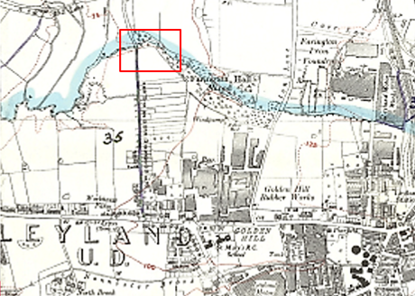
Observations |  | Leyland Urban District Council prepared a Draft Map of the area. Th e application route was not shown on the Draft Map and no representations or objections made relating to it.
Provisional Map |  | Once all representations relating to the publication of the draft map were resolved, the amended Draft Map became the Provisional Map which was published in 1960, and was available for 28 days for inspection. At this stage, only landowners, lessees and tenants could apply for amendments to the map, but the public could not. Objections by this stage had to be made to the Crown Court.
Observations |  | The application route is not recorded on the Provisional Map and no representations were made relating to it.
The First Definitive Map and Statement |  | The Provisional Map, as amended, was published as the Definitive Map in 1962.
Observations |  | The application route was not recorded on the First Definitive Map.
Revised Definitive Map of Public Rights of Way (First Review) |  | Legislation required that the Definitive Map be reviewed, and legal changes such as diversion orders, extinguishment orders and creation orders be incorporated into a Definitive Map First Review. On 25th April 1975 (except in small areas of the County) the Revised Definitive Map of Public Rights of Way (First Review) was published with a relevant date of 1st September 1966. No further reviews of the Definitive Map have been carried out. However, since the coming into operation of the Wildlife and Countryside Act 1981, the Definitive Map has been subject to a continuous review process.
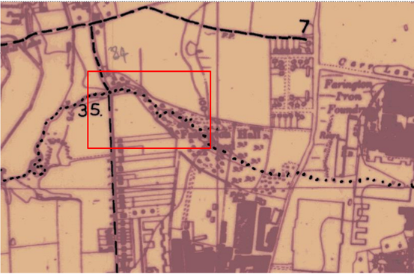
Observations |  | The application route is not recorded on the Revised Definitive Map (First Review).
Investigating Officer's Comments |  | The application route does not appear to have been considered to be a public path which should have been recorded on the Definitive Map and Statement during the relevant period.
Highway Adoption Records including maps derived from the '1929 Handover Maps' | 1929 to present day | In 1929 the responsibility for district highways passed from rural district councils and later that of the urban districts and boroughs passed to the County Council. For the purposes of the transfer, public highway 'handover' maps were drawn up to identify all of the public highways within the county. These were based on existing Ordnance Survey maps and edited to mark those routes that were public. However, they suffered from several flaws – most particularly, if a right of way was not surfaced it was often not recorded.  A right of way marked on the map is good evidence but many public highways that existed both before and after the handover are not marked. In addition, the handover maps did not have the benefit of any sort of public consultation or scrutiny which may have picked up mistakes or omissions.  The County Council is now required to maintain, under section 31 of the Highways Act 1980, an up to date List of Streets showing which 'streets' are maintained at public expense. Whether a road is maintainable at public expense or not does not determine whether it is a highway or not.
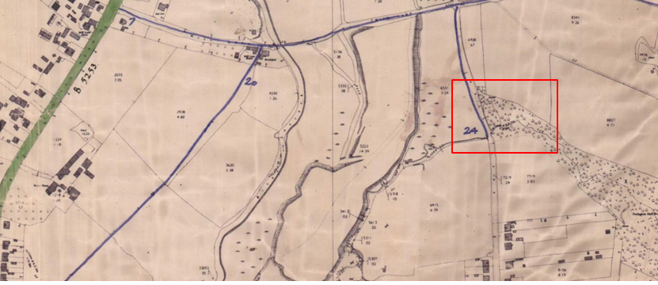
Observations |  | The provenance of the plan for Leyland is not known, this may have been or derived from the time of the handover but became the working plan for highway maintenance. The application route is not shown.  The application route is not recorded as a publicly maintainable highway on the List of Streets.
Investigating Officer's Comments |  | The fact that the route is not recorded as a publicly maintainable highway does not mean that it does not carry public rights of way so no inference can be drawn.
Highway Stopping Up Orders | 1835 - 2014 | Details of diversion and stopping up orders made by the Justices of the Peace and later by the Magistrates Court are held at the County Records Office from 1835 through to the 1960s. Further records held at the County Records Office contain highway orders made by Districts and the County Council since that date.
Observations |  | No legal orders relating to the creation, diversion or extinguishment of public rights have been found.
Investigating Officer's Comments |  | If public rights are found to exist along the application route they do not appear to have been subsequently diverted or extinguished by a legal order.
Statutory deposit and declaration made under section 31(6) Highways Act 1980 |  | The owner of land may at any time deposit with the County Council a map and statement indicating what (if any) ways over the land he admits to having been dedicated as highways. A statutory declaration may then be made by that landowner or by his successors in title within ten years from the date of the deposit (or within ten years from the date on which any previous declaration was last lodged) affording protection to a landowner against a claim being made for a public right of way on the basis of future use (always provided that there is no other evidence of an intention to dedicate a public right of way).  Depositing a map, statement and declaration does not take away any rights which have already been established through past use. However, depositing the documents will immediately fix a point at which any unacknowledged rights are brought into question. The onus will then be on anyone claiming that a right of way exists to demonstrate that it has already been established. Under deemed statutory dedication the 20 year period would thus be counted back from the date of the declaration (or from any earlier act that effectively brought the status of the route into question).
Observations |  | Prior to the application route being fenced off in November 2020 no Highways Act 1980 Section 31(6) deposits had been lodged with the county council for the area over which the application route runs.  On 26th January 2021 the current landowner emailed Lancashire County Council with an application to submit a deposit under the 1980 Act. This deposit was still in the process of being delt with at the time this report was written.  In his email, the landowner said that he completed on the purchase of the land in October 2020 and subsequently notified ‘locals’ that access was not permitted. He stated that he subsequently erected fencing on 22nd November which prevented access but that this was subsequently vandalised. He explained that he purchased the land from the Duchy of Lancaster and that being Crown land, would not have been subject to anyone claiming public rights of access across it.
Investigating Officer's Comments |  | Prior to January 2021 there was no indication by any landowner under the provisions set out in the Highways Act 1980 of non-intention to dedicate public rights of way over this land.  Other issues raised by the current landowner with regards to landownership and challenges to the public's use of the route will be discussed later in this report.
Photographs submitted by the applicant | 2020-2021 | A selection of the photographs of the application route submitted by the applicant showing the route before and after it was obstructed in November 2020.
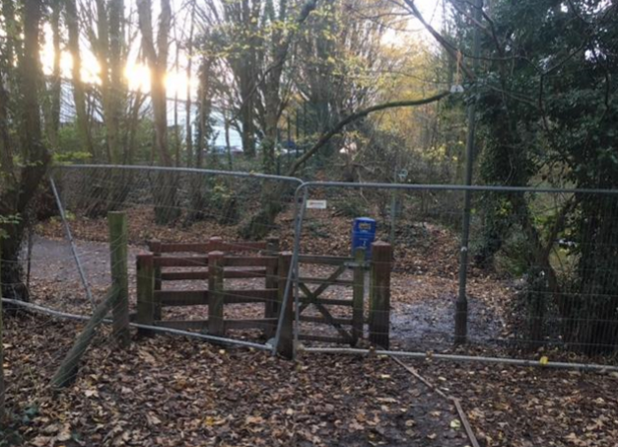
Looking towards Hall Lane (Leyland Footpath 35) from the application route – November 2020
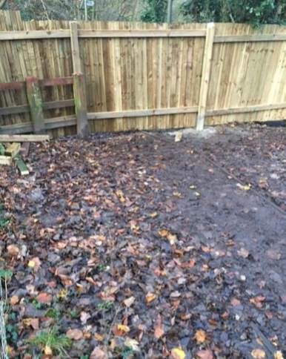
Looking towards Hall Lane (Leyland Footpath 35) from the application route – December 2020
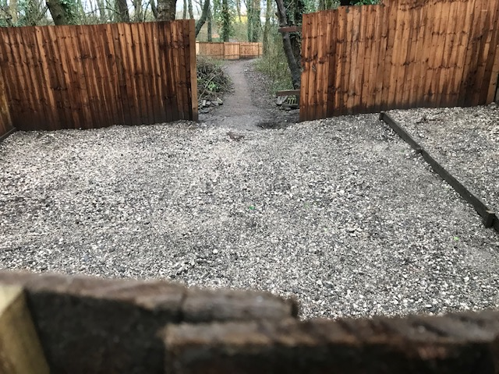
Undated photograph submitted February 2021 of application route from point A
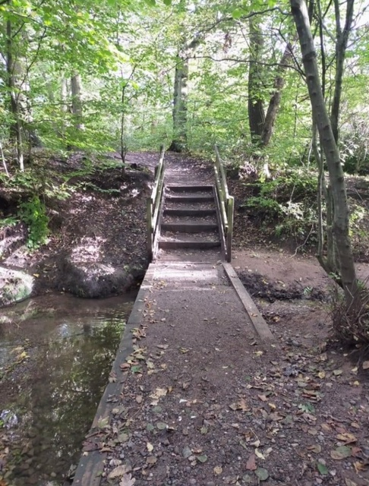
Ditch crossing at point C and steps leading to point D prior to installation of the fence. Photograph undated.
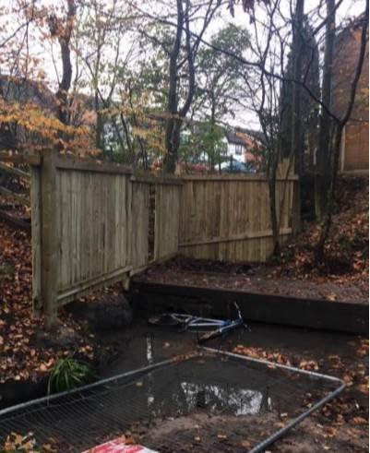
Route at pont C showing ditch crossing stated to have been constructed by LCC in 2014. Photograph taken November 2020
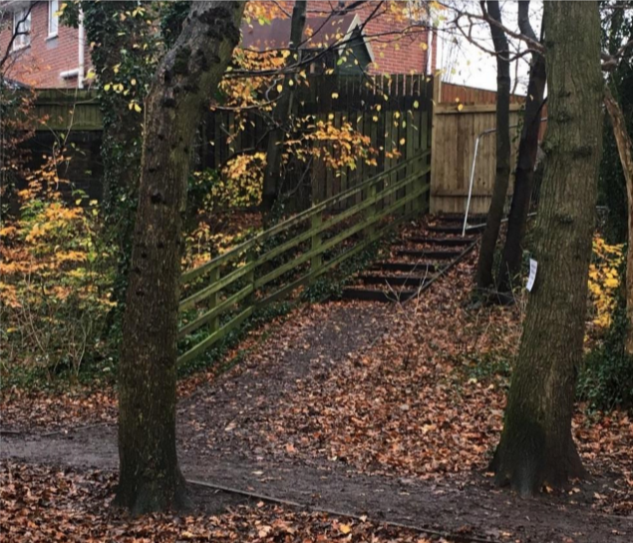
Point B looking up steps to point F November 2020
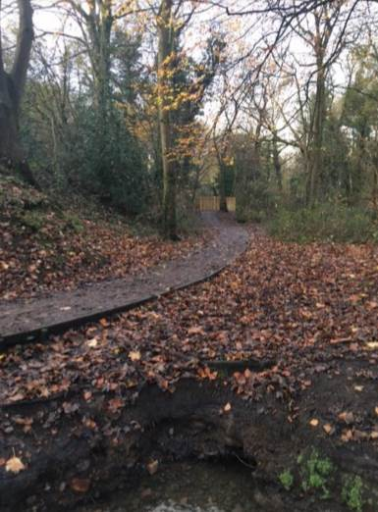
View of application route between point B and point A November 2020
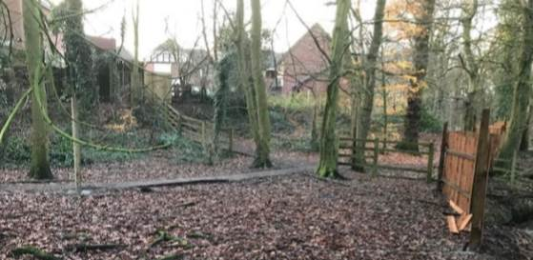
Application route with spur to Bluebell Wood shown – November 2020
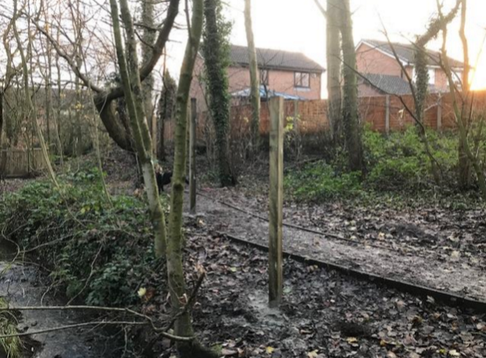
Further photograph showing the constructed path between point A and point B – November 2020
Observations |  | The photographs submitted show the route as it existed before and during the time in which it was being fenced off.
Investigating officer’s Comments |  | The photographs are useful in confirming the existence of a surfaced path through the woodland and existence of kissing gates at point a and point F. They support the information given in the user evidence forms and the existence of a route as shown on modern OS base mapping.

The affected land is not designated as access land under the Countryside and Rights of Way Act 2000 and is not registered common land.

Landownership

The application route between points A-B-C and F-B

The applicant makes reference to the field on which the houses were built being used as football pitches and being owned by ‘the Iddon brothers’.

Ownership of this land prior to 1990 seems to have been with BTR Property Holdings and the Land Registry title states they sold to Marland Bros Ltd in 1990.

The land crossed by the application route between points A-B-C and F-B was in the registered landownership of Chapeltown Estates Limited (Title LA652563) from 01.03.1996. Chapeltown Estates Ltd changed its name to Chapeltown Homes Ltd in 1998. This registration remained until recently even though property escheated to the Crown in 2010 and was sold in 2020.

The Registered Title refers to a number of restrictive covenants which the current landowner has referred to, one of which relates to the requirement to maintain a concrete post and three strand fence between point A and point B on the Land Registry plan which would effectively cross the application route at point C and to at all times to repair, maintain and where necessary replace this fence. The covenant does not appear to include the requirement for fencing across the start of the route at point A (as marked on the Committee plan).

Information obtained from Companies House shows that Chapeltown Homes Limited was dissolved on 8 December 2010.

It is understood from the Duchy that when Chapeltown Homes Limited went into administration the liquidators discharged their interest and the land reverted to the Duchy of Lancaster.

The current owner of the woodland between points A-B-C and B-F purchased the site from the Duchy of Lancaster in October 2020. He is now the registered owner.

The application route between point C-D

A thin strip of land crossed by the application route between point C and point D is registered as Title LA 935671 and is owned by Taylor Wimpey Developments Limited who purchased a large plot of land in 2003 as part of ‘The Oaks’ Development. All but the thin strip of land crossed by the application route was subsequently sold off when the development was completed with the woodland east of point D sold to Greenbelt Ltd and retained as public open space with footpath works funded through leaseholder charges to properties on ‘The Oaks’.

Signage from ‘The Oaks’ into the woodland suggests that access is available to the public at large stating ‘Welcome: this area of Open space is managed and maintained by Greenbelt Group Ltd.’

The application route between point E and point F

The land crossed by the application route is in private ownership and was purchased by the present owner in February 2017.

Summary

The woods through which the application route runs have existed since at least the early 1800s and have largely remained unaltered.

However, no map or documentary evidence pre-1995 supports the view that the application route was in existence before that time and although there may have been access to and through the woodland earlier than 1995 the Investigating Officer found insufficient evidence from which to infer that a public footpath existed.

In 1995 planning permission was granted for the development of a housing estate on fields between Hall Lane and the woodland and as part of the application process the developer submitted a report relating specifically to Farington Hall Wood. The report made a number of references to an existing trodden path through the site consistent with the application route between points A-B-C-D and as part of the development the landowners proposed to surface the path and to provide additional links to the development. It therefore appears that a route did exist through the woodland prior to 1995/1996 consistent with the user evidence submitted.

The application route between points E-F-B did not however exist prior to the construction of the properties on Bluebell Wood.

Map and documentary evidence, together with site photographs supplied as part of the application all confirm that the full length of the application route existed following the development of the site with links to public highways at point A and point E and that the route continued from point D along a network of paths through the woodland to the south east which is managed privately as public open space.

Head of Service – Legal and Democratic Services Observations

Information from the Applicant

The Applicant provided the following information:

- An Application to modify the DMMO to add footpath(s) in Farington Hall Wood
- Map(s) extract marking existing 'paths'
- A Map showing the route of the 'proposed' DMMO.
- A 20 page background document – within it are pictures, maps and further commentary supporting the application.
- Photographs of the 'proposed' footpath fenced off
- A spreadsheet listing the User Evidence Statements collected to date.
- Scanned copies of the physical forms collected.
- 84 user Evidence Forms.

The 84 user forms have been carefully considered and the information set out below

Duration of Use

The user evidence forms collectively provide evidence of use going back as far 1960 and up to 2020 when the application route was blocked by the current landowner of A-D and B-F, and the application to record the right of way was made. All refer to use up to 2020 but their periods of use depend on when they started to use the route.

Started to use the route or more probably only A-D prior to 1995 | Started to use the routes A-D and E-F- B  between 1995 - 2010 | Started to use the routes between 2010 and 2020 | Not Specified
11 | 46 | 26 | 1

Frequency of Use

The majority of the 84 users stated that they used the route daily or weekly, with two stating that they used the route more than once per day. One user specified that they used the route twice a month and six did not specify.

More than once daily | Daily | Weekly | Fortnightly | Monthly | Every few months | Not Specified
2 | 37 | 28 | 1 | 5 | 5 | 6

Reasons for use

Of those who specified their reason for using the route, the most common answer was pleasure/leisure/exercise/recreational closely followed by do walking. Others noted family walks, walking to the shops and six did not specify.

All but eight stated the use of foot, one stated use as foot and horseback, three stated use as foot and bicycle, and 4 did not specify.

Dog Walking | Pleasure/Leisure/Exercise/ Recreational | Walking to the shops | Family Walks | Not Specified
36 | 40 | 1 | 1 | 6

Other Users of the Route

The majority of the users recorded having seen others on foot whilst using the route, nineteen users recorded having seen others using the route on foot & bicycle. Three have stated they saw others using the route for access to the shops i.e. Morrisons.

Consistency of the Route

The majority of the 84 users stated that the route had always followed the same route, of those seven stated they don't know, one stated no and sixteen did not specify.

Has the Application Route Always Followed Same Course?

Yes | No | Don't know | Not Specified
60 | 1 | 7 | 16

Route Used

In the Committee Plan, the proposed footpath was marked out at different points from A to F highlighting the route, the users illustrated on the plan provided within the user evidence forms where they would walk along the route.

A,B,C,D,E,F  (Full length of the route) | Part length of the route | No map | Illegible map | None stated
62 | 1 | 10 | 1 | 10

Unobstructed use of the Route

None of the 84 users recalled having been prevented from using the route. 55 have specified they were only prevented from using the route in November 2020 onwards.

All but eight of the users had seen either no signs nor notices restricting or prohibiting access to the route. Seventy-one have stated they saw the private land signs after November 2020, which prompted the application.

69 users were aware of no stiles along the route, one responded they didn't know, five stated yes and nine did not specify.

75 users stated there are kissing gates at Hall Lane and Bluebell Wood, nine did not specify.

50 of the users have expressed they have the right to use the land as a footpath, and believe they were given permission under the Bluebell Housing Public Open Space ref:07/95/0674.

Information from Landowners

There are two landowners who have a registered interest in this matter who have responded.

The landowner of section E to F responded to the consultation, first confirming his landownership, he states that the footpath running from the Bluebell Wood cul-de-sac runs through which he is the owner.

This landowner stated he does not have any objections to the DMMO, so long as the footpath follows its original line (he refers to the map of the footpath illustrated in the committee plan).

He further stated that "In fact, the kissing gate entrance to the set of steps leading down into the woodland falls on my land and I have decided not it or fence off that area of my land. This is with the view that there is overwhelming evidence of the footpath's being used and maintained for decades. As such I expect that there is a high probability of the footpath becoming official and reopening once again."

As such he expects it is very likely the proposed footpath will become official and re-opened to the public again.

The landowner of section A to C and B to E confirmed his additional landownership of A-D and B-F stating that the Land Registry the title of the additional land was transferred to him on 8 March 2021. (The Title instead refers to his purchase being October 2020), this landowner had parts of the land fenced off at points that crossed the proposed footpath.

This landowner went on to state that his interpretation of the extract from the Official copy of the Register (please see below) that any 'rights' assumed up to the date have been extinguished and the vendor/purchase had no intention to give permitted access going forward.

(22.08.1990) The Conveyance dated 7 August 1990 referred to above
contains the following provision:-

"IT IS HEREBY AGREED AND DECLARED by and between the parties hereto as
follows:-

(i) Any rights easements quasi-rights quasi-easements and privileges
enjoyed as at the date hereof by the property hereby conveyed over
under or through the Retained Land and all other neighbouring and
adjoining land of the Vendor and the Purchaser shall be extinguished
forthwith

This landowner left a post on 'The Leyland Hub' stating he had purchased part of Farington Woods, and he had carried out an inspection on the site and had noticed some trees have fallen, resting on a tree that is upright, and as a result of this he had it fenced off, he acknowledged that he had blocked part of the route and cited health and safety concerns.

This landowner also stated the following in his correspondence:

The following are details of the covenants contained in the Conveyance
dated 7 August 1990 referred to in the Charges Register:-

Between the points marked 'A' and 'B' on the said plan a concrete post
and three strand wire fence not less than four feet in height or such
other type of boundary demarcation as may be specified by the local
Planning Authority

(v) In the event of any breach non-observance or non-performance of the
covenants set out in clause 2 (i) hereof to permit the Vendor to enter
upon so much of the property hereby conveyed as may be reasonable for
the purpose with or without workmen plant or machinery to remedy such
breach non-observance or non-performance as aforesaid and forthwith
upon written demand therefor to pay the costs of the Vendor or the
Purchaser as the case may be of such remedial works as aforesaid
together with interest at 5% per annum above the Base Rate for the time
being of the Midland Bank PLC from the date of demand to the date of
actual payment

NOTE: The land edged blue and coloured blue in part referred to above
is edged yellow on the title plan. The points A, B, C and D referred to
are lettered A, B, C and D on the title plan

(Application route point C is on title plan line A-B.)

The landowner of section A to C and B to E states that the above would imply that the land was intended from 7th August 1990 to have some form of fencing in place to enclose the said piece of land, to the point where if a fence was not to be erected then the seller could carry out the action themselves and recharge that to the purchaser.

This landowner went on to state that Chapeltown Homes Limited went into liquidation in 2010, and as a result the land fell into the ownership of the Duchy of Lancaster. He further states The Duchy of Lancaster is protected from Public Rights of Way applications, to which he suggests that the 20-year period of unrestricted use has technically been restricted due to the special circumstances in change of ownership to the Crown until the change of ownership in 2020. This landowner argues that the 20-year trigger point would start from when he purchased the land.

Since he has purchased the land this landowner has made it clear to the public that access is now restricted, thus challenging any public rights. He believes the evidence submitted has implied that South Ribble Borough Council laid a hard surface through the plot of land at some point between 2010 and 2020. This landowner wanted confirmation from South Ribble Borough Council, that they contacted The Duchy of Lancaster seeking permission, and if it was granted in order to lay the surface in the first instance. To which he further adds that it is his opinion that during the process of laying of the surface access was restricted and as such there would have been a break in the qualified period.

Conclusion

As there is no express dedication the Committee are invited to consider whether S31 deemed dedication provisions can apply and also consider whether any dedication cam be inferred at common law from all the circumstances.

In this matter the application route links to existing highway at point E and A but also reaches a point of public resort at D namely the land managed as Public Open Space.

Looking at S31, in this application the route is affected by the ten-year period when the main section of the route was held by the Duchy. There is a calling into question in 2020 by fences being erected across the route by the owner of A-C and B-F but S31 cannot apply to the Duchy as under S327 Highways Act for the Highways Act provision to apply to the Crown there would need to be an agreement with the Duchy which there was not.

Use in the period before 2010 is still significant but does not end with a calling into question such that users were in any way appraised of any challenge and so S31 is difficult to apply to any periods of use in this matter.

Turning however to looking at whether dedication can be inferred from all the circumstances at common law, it is the case that highways can still be inferred at common law on Crown land so before and even while the Duchy held the land dedication may be able to be inferred from the circumstances

The circumstances in this matter from which a landowner's intention might be inferred on balance would seem to be the use by the public as of right, the intention expressed in the owners' planning application and the nature walk promoted in their site plan by Chapeltown when they purchased 1995/6, the physical creation of route E-F and the use to 2020 and the work on the route in 2014.

It is advised that Committee may be content that use has been by the public and use by sufficient number in particular from 1995 through the ownership of Chapeltown Estates Ltd (later called Chapeltown Homes Ltd). The numbers of users is high – see above. The use was such as might reasonably have been expected if the way had been unquestionably a public highway. The use would have appeared open to the owner.

The use has to have been as of right. There is no suggestion that use was secretive or involved forcibly getting onto the land. However, there is reference to users thinking they had permission given the nature of the Public Open Space reference on land to the east. It is advised that this is not actual permission from the owner, but instead it is a perception of there being no challenge to their use.

It appears that notwithstanding the reference in the conveyance to a requirement for a fence there was no fence erected across the application route in consequence of this and the route remained without restriction until the fence erected in 2020 by the current landowner.

Common law needs consideration of evidence of an intention to dedicate. Where there is satisfactory evidence of user by the public dedication may be inferred but here in addition there are actual actions taken by the owner. Irrespective of any private covenant to fence point C in the title, there was clearly no such fence given the public use and there is the way the route is described in Chapeltown's planning application, there is the reference to the route being a nature trail and linking further east in the sales brochure. There is the work done on the ground in 2014 by the County Council to improve the existing route. The registered owner remained showing as Chapeltown but actual ownership had passed to the Duchy who took no issue with the works to improve the existing public use along the application route. The works will not have impacted or interrupted use as it is normal practice to take mitigation measures to ensure public safety rather than try to prevent use during minor works.

As the route passes into different ownership at the brook C-D Taylor Wimpey have made no comment and have for many years acquiesced in public use across their strip of land at this location.

The section E-F likewise is in a different ownership and the owner seems content that the route will be available for public use again (see above). It is taken that he says that he decided not to remove the set of steps or fence off that area of his land. This part of the route will have originally been in Chapeltown ownership and constructed as an access for use.

It is therefore advised that there may be considered to be sufficient evidence from which to infer dedication at common law on balance from all the circumstances including the use by the public during the Chapeltown ownership and possibly even 2010-2020 when it was held by the Duchy. The recommendation is therefore that an Order be made and promoted to confirmation.

Risk management

Consideration has been given to the risk management implications associated with this claim. The Committee is advised that the decision taken must be based solely on the evidence contained within the report, and on the guidance contained both in the report and within Annex 'A' included in the Agenda Papers. Provided any decision is taken strictly in accordance with the above then there is no significant risks associated with the decision making process.

Local Government (Access to Information) Act 1985

List of Background Papers

Paper | Date | Contact/Directorate/Tel
All documents on File Ref: 804-691 |  | Ansar Sadiq, Legal Governance and Registrars Service. 01772 532435
Reason for inclusion in Part II, if appropriate

N/A

The Ordnance Survey (OS) has produced topographic maps at different scales (historically one inch to one mile, six inches to one mile and 1:2500 scale which is approximately 25 inches to one mile). Ordnance Survey mapping began in Lancashire in the late 1830s with the 6-inch maps being published in the 1840s. The large scale 25-inch maps which were first published in the 1890s provide good evidence of the position of routes at the time of survey and of the position of buildings and other structures. They generally do not provide evidence of the legal status of routes, and carry a disclaimer that the depiction of a path or track is no evidence of the existence of a public right of way.
Aerial photographs can show the existence of paths and tracks, especially across open areas, and changes to buildings and field boundaries for example. Sometimes it is not possible to enlarge the photos and retain their clarity, and there can also be problems with trees and shadows obscuring relevant features.

